Lab 2 — Control Structures in C++
🎯 Objectives
By the end of this lab, you will be able to:
✅ Use relational and logical operators.
✅ Apply if, if…else, and nested if statements.
✅ Use the switch statement.
✅ Understand short-circuit evaluation.
✅ Build a complete program using selection structures.

🔹 Part 1 — Relational and Logical Operators
❓ Question 1
Write a program that uses relational operators to compare two integers and print the results.
✅ Answer
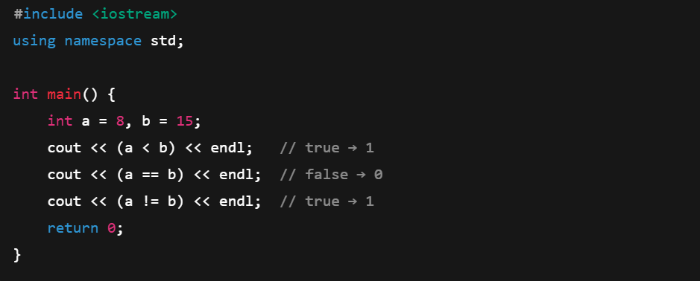

❓ Question 2
Use logical operators to test whether two conditions are both true.
✅ Answer
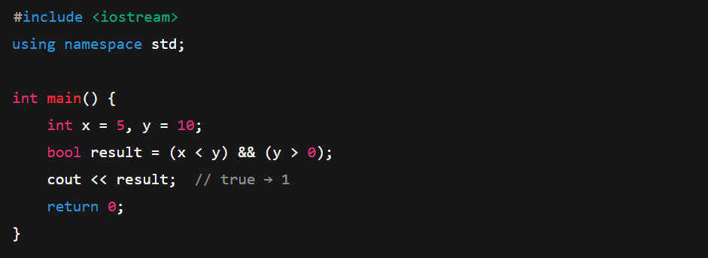

❓ Question 3
Ask the user for two numbers and print:
- whether the first is greater than the second, and
- whether both numbers are positive.
✅ Answer
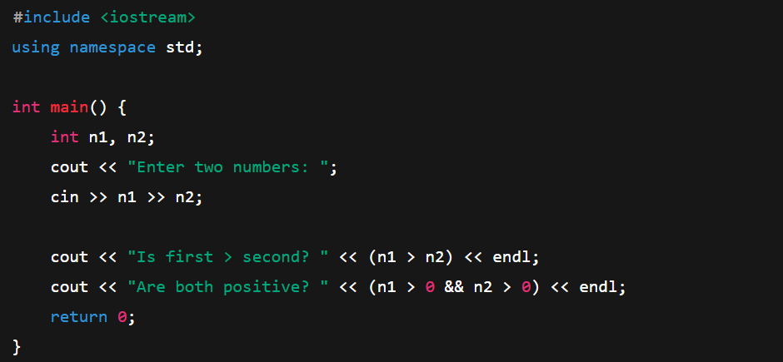
🔹 Part 2 — Using if and if…else
❓ Question 4
Write a one-way selection program that prints “Eligible to vote” only if the user’s age is 18 or more.
✅ Answer
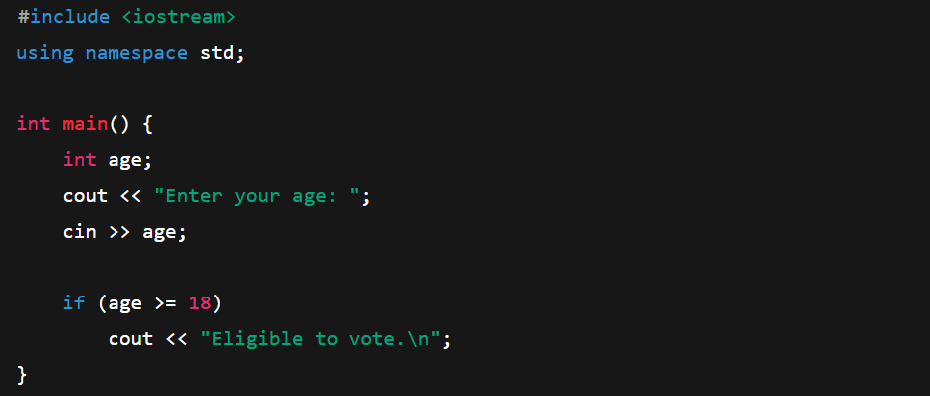

❓ Question 5
Write a two-way selection program that prints
- “Excellent!” if the grade is A,
- otherwise “Keep trying!”
✅ Answer
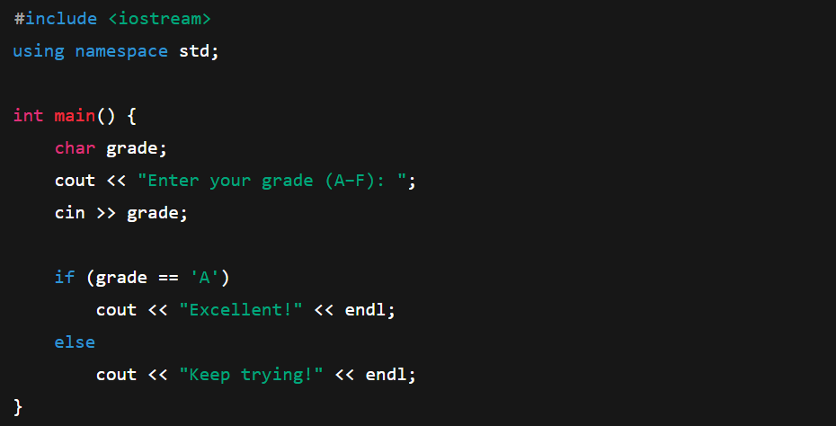

🔹 Part 3 — Nested if
❓ Question 6
Write a program that asks for a score and prints both a letter grade and a message.
✅ Answer
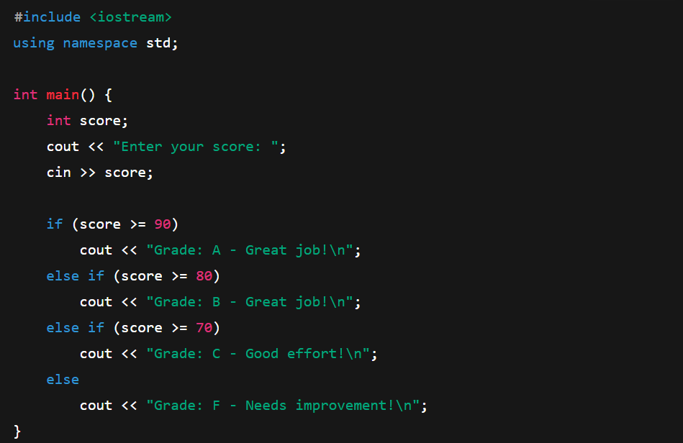

🔹 Part 4 — Short-Circuit Evaluation
❓ Question 7
Why doesn’t this expression cause an error?
(x != 0 && (10 / x) > 1)
✅ Answer (Code + Explanation)
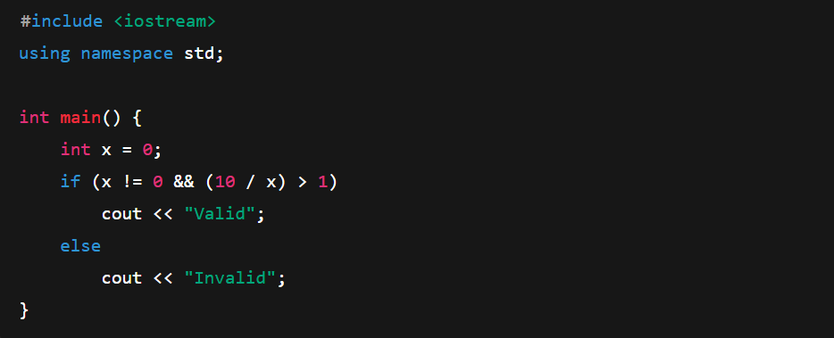
🧠 Explanation:
Because of short-circuit evaluation, the second condition (10 / x) > 1 is never checked when x != 0 is false, so no division by zero occurs.

🔹 Part 5 — Switch Statement
❓ Question 8
Write a program using a switch statement that prints the month name for numbers 1–4.
✅ Answer
